Assignment 4 SDP

Kuanysh Beibarys SE-2413

Builder Pattern

Builder pattern was used for theme Programming Languages and necessary Themes

Languages: Java, Python, JavaScript

Themes: OOP, Libraries, Frameworks

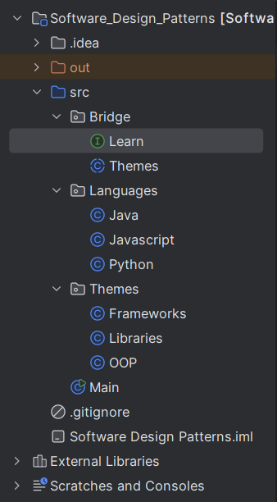

The Learn interface defines the implementation part (different programming languages like Java, Python, Javascript).

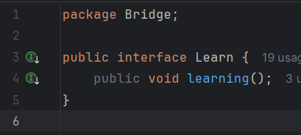

The Themes abstract class defines the abstraction part (different learning themes such as OOP, Libraries, Frameworks) and holds a reference to a Learn object.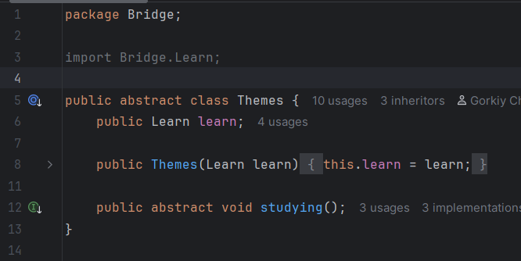

Concrete classes such as OOP, Libraries, and Frameworks extend Themes to provide specific topics, while concrete classes such as Java, Python, and Javascript implement Learn to provide specific languages.

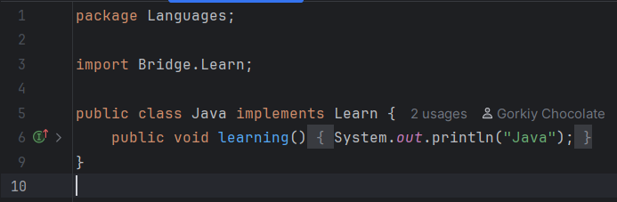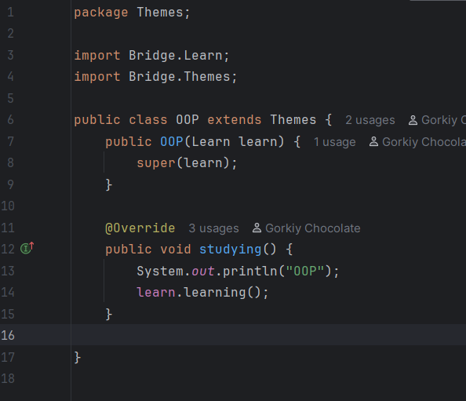

In Main, different combinations of themes and languages are created to show how abstraction and implementation can vary independently.

